Challenge Number: 1021
Played on date: October 20, 2023 Time: 19:00
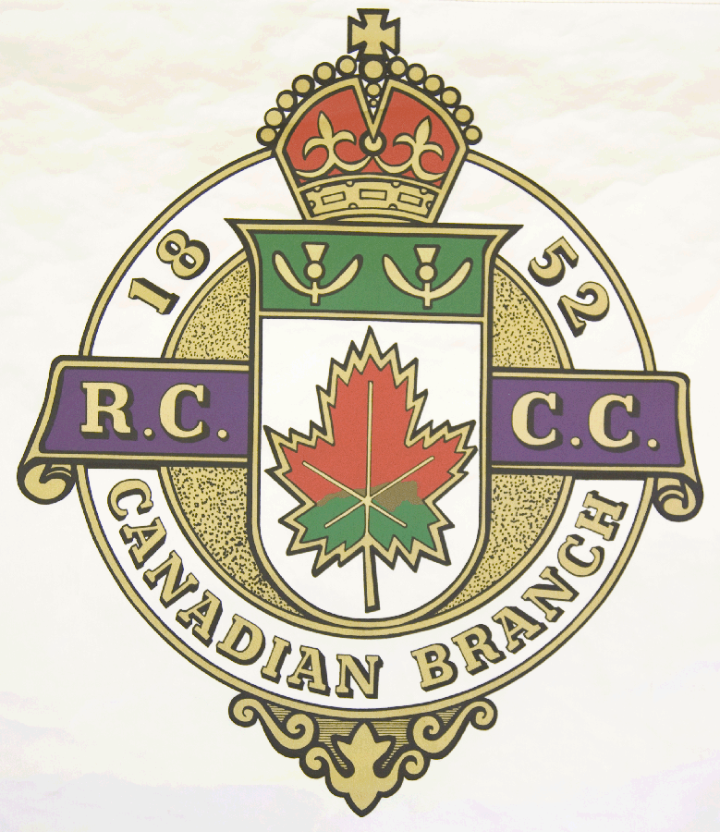
Hosting Club: North Hatley Curling Club

Host Club Address: 3245 Chemin Capelton

Host Club City: North Hatley, Qc.

Host Club Telephone: 819 - 842 - 2655

Host Contact Person: Marty Rourke

Contact phone or email: mrourke@ubishops.ca

Hosting Club: North Hatley Challenging Club: Cornwall

Skip: Matt McCrea Skip: Matt Dupuis

Third: Josh Bronson Third: Charles West

Second: Dan Camber Second: Jon King

Lead: John McCrea Lead: Sam Mainville

Skip: Marty Rourke Skip: Al Solari

Third: Steve McPherson Third: Tyler Benson

Second: Joe Cox Second: Angelo Giovanniello

Lead: Marc Cote Lead: Greg Camm .

 | Skip | 1 | 2 | 3 | 4 | 5 | 6 | 7 | 8 | 9 | 10 | Score
Sheet  1 | M. McCrea | 2 | 1 | 0 | 0 | 0 | 0 | 1 | 0 | X | X | 4
Sheet  1 | M. Dupuis | 0 | 0 | 1 | 0 | 1 | 1 | 0 | 1 | X | X | 4
Sheet  2 | M. Rourke | 2 | 0 | 0 | 3 | 0 | 2 | 3 | 0 | X | X | 10
Sheet  2 | A, Solari | 0 | 1 | 0 | 0 | 2 | 0 | 0 | 1 | X | X | 4

Hosting club score: 14____ Challenging club score: __ 8____

